**Controlling RGB LED By PWM using Tinkercad**

An **RGB LED** (Red, Green, Blue Light Emitting Diode) is a type of LED (Light Emitting Diode) that combines three separate LED elements (red, green, and blue) into one package. By adjusting the brightness of each of these individual LEDs, an RGB LED can produce a wide spectrum of colors.

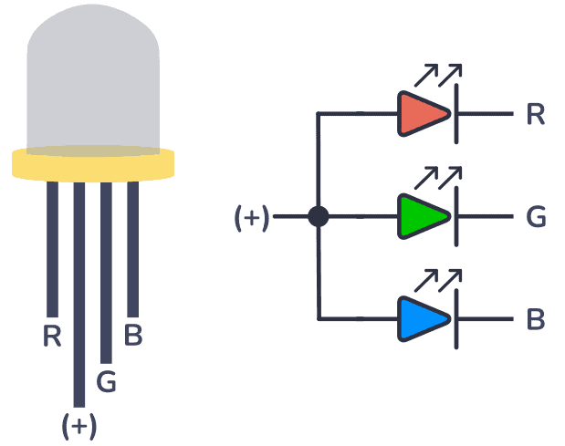

**How an RGB LED Works:**

An RGB LED contains three distinct LEDs (red, green, and blue), and each of these LEDs can be controlled independently to create different colors. By varying the intensity of each LED, you can mix the three primary colors of light (red, green, and blue) to create any color in the visible spectrum.

1. **Red, Green, and Blue LEDs**:
   * The **Red LED** emits light in the red portion of the spectrum.
   * The **Green LED** emits light in the green portion of the spectrum.
   * The **Blue LED** emits light in the blue portion of the spectrum.
2. **Color Mixing**:
   * By varying the intensity of each LED, you can mix the colors to produce a wide range of colors. For example:
     + **Red + Green** = Yellow
     + **Green + Blue** = Cyan
     + **Red + Blue** = Magenta
     + **Red + Green + Blue** = White (if the intensities of all three LEDs are set equally)
     + Any other color is made by adjusting the brightness of each of the three LEDs accordingly.
3. **PWM (Pulse Width Modulation)**:
   * To control the brightness of each of the three LEDs, **Pulse Width Modulation (PWM)** is often used. PWM allows you to adjust the "on" time of each LED, thereby controlling its brightness.
   * For example, a higher duty cycle (longer "on" time) means brighter light, while a lower duty cycle means dimmer light.

**Example Color Mixing:**

* **Red**: Red LED at full brightness, Green and Blue LEDs off.
* **Green**: Green LED at full brightness, Red and Blue LEDs off.
* **Blue**: Blue LED at full brightness, Red and Green LEDs off.
* **Yellow**: Red and Green LEDs at full brightness, Blue LED off.
* **White**: All three LEDs at full brightness.

**Types of RGB LEDs:**

1. **Common Cathode RGB LED**: All the negative terminals (cathodes) of the three LEDs are connected together and are typically connected to ground. Each LED's positive terminal is controlled individually.
2. **Common Anode RGB LED**: All the positive terminals (anodes) of the three LEDs are connected together and are typically connected to a positive voltage (e.g., 5V). Each LED's negative terminal is controlled individually.
3. **Explanation** :

When you control an RGB LED using PWM with an Arduino, the circuit allows you to adjust the brightness of each color (red, green, and blue) independently. The Arduino is connected to the RGB LED through three pins, one for each of the red, green, and blue color channels. The Arduino controls the intensity of each color using PWM (Pulse Width Modulation), which allows it to simulate varying brightness levels by switching the LEDs on and off rapidly.

Each of the three LEDs in the RGB package is connected to a PWM-capable pin on the Arduino, and the analogWrite() function is used to control the brightness of each LED. When you call analogWrite(pin, value), it sends a PWM signal where the value can range from 0 to 255. A value of 0 means the LED is off, and a value of 255 means the LED is fully on. Intermediate values adjust the brightness accordingly.

In the circuit, when you change the PWM values for each color, the Arduino adjusts the duty cycle of the PWM signal. This means the amount of time the LED is on versus off during each cycle. For example, if you set the red LED to 128, it will be on half the time and off the other half, resulting in a dimmer red light. By adjusting the PWM values for the red, green, and blue LEDs independently, you can mix them to create a wide range of colors.

For instance, if you set all three LEDs (red, green, and blue) to the same intensity, you will get white light. If you set only the red and green LEDs to high values, you’ll get yellow, and so on. The RGB LED, controlled by the Arduino, will change its color based on the PWM values assigned to each channel, allowing you to create various lighting effects. The result is the ability to create millions of colors by mixing different intensities of red, green, and blue light.